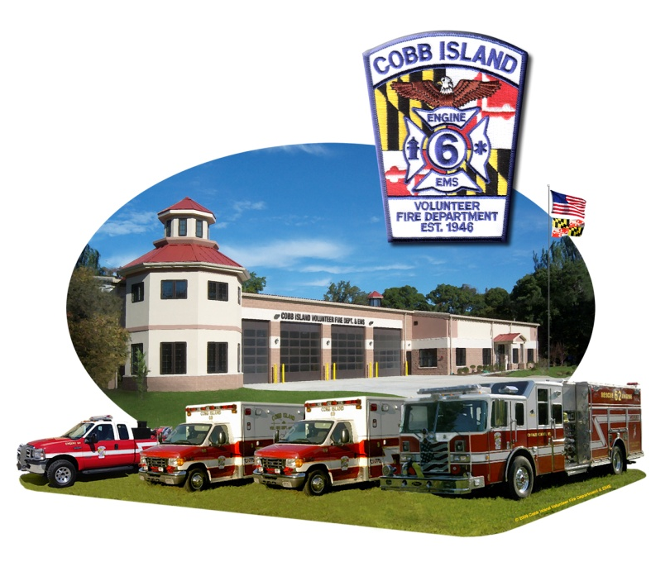

Annual Oyster and Ham Dinner

(Fried Oysters, Stuffed Ham, Regular Ham, Sweet Potatoes,
Green Beans, Corn, Cole Slaw, Rolls, Coffee, Tea)

Sun., Nov. 3, 2013
12:00 – 5:00 p.m.

Adults - $23.00

Children 6 to 10 - $12.00

Children 5 and under free

Oyster Scald Available

Raffles, 50-50, Bake Sale, Pull Tabs

Enjoy a meal with your family and friends!

Come Support and Meet your

Local Fire Department Volunteers!

